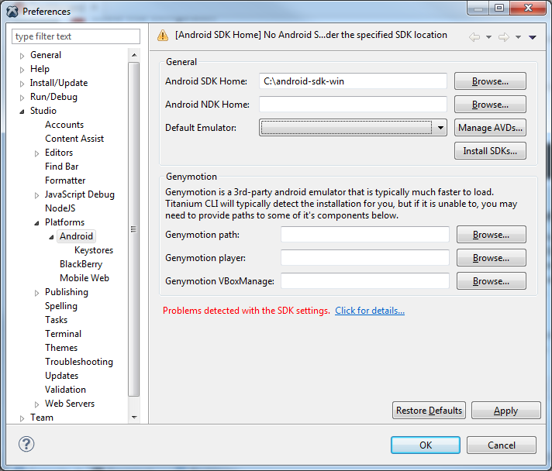
Clicking on “Click for details…”:
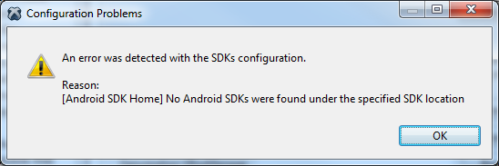
Clicking on “Install SDKs…”:
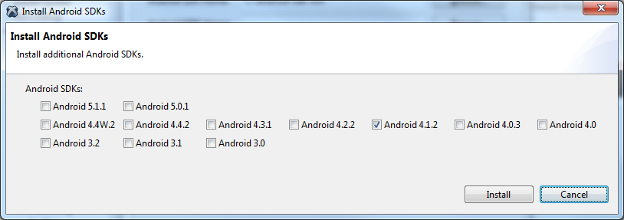
I choose Android versions I need, the process starts:
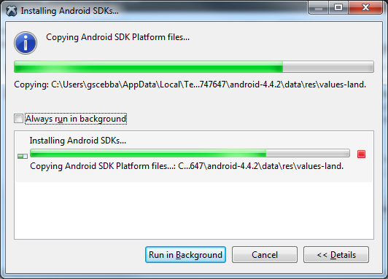
At the end, I don’t see anything installed.

