NFC
For iOS - https://developer.apple.com/documentation/corenfc

Core NFC - Detect NFC tags, read messages that contain NDEF data, and save data to writable tags.
Using Core NFC, you can read Near Field Communication (NFC) tags of types 1 through 5 that contain data in the NFC Data Exchange Format (NDEF).

What is Ndef?

The NFC Data Exchange Format (NDEF) is a standardised data format that can be used to exchange information between any compatible NFC device and another NFC device or tag. The data format consists of NDEF Messages and NDEF Records.

App write data to tags, and interact with protocol specific tag such as
ISO 7816 – Type 4 – MiFare DesFire
ISO 15693- Type 5- ISO/IEC15693
FeliCa™ - Type 3
MIFARE® tags- Type 2 -MIfare Ultralight C
Src - https://www.themobileknowledge.com/wp-content/uploads/2018/03/02-Webinar-slides-NFC-essentials.pdf
Src - https://www.dummies.com/consumer-electronics/5-nfc-tag-types/

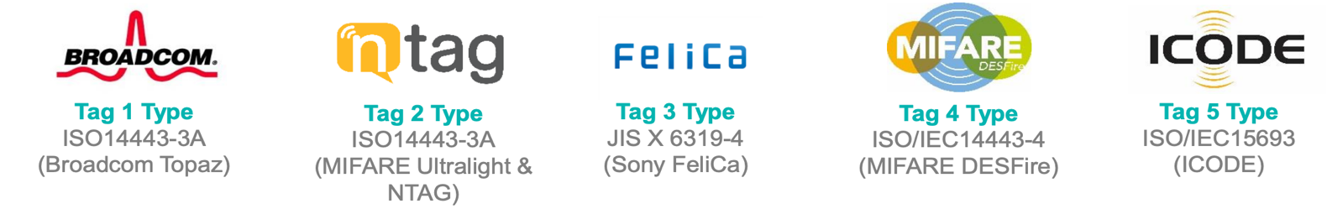

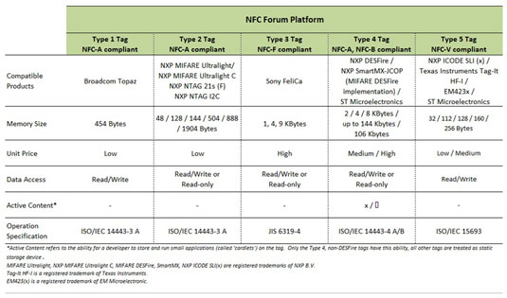

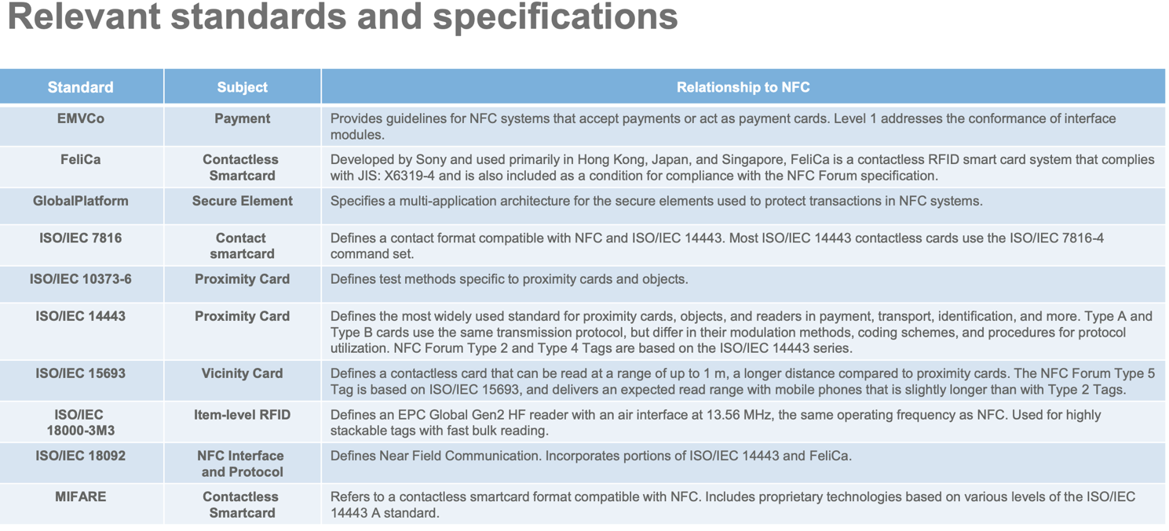

-----------------------------------------------------------------------------

For Android - https://developer.android.com/reference/android/nfc/tech/package-summary

Classes used by android.nfc.tag---
ISO-Dep – Type 4- (ISO 14443-4) Mifare Desfire Provides access to ISO-DEP (ISO 14443-4) properties and I/O operations.
Mifare classic - Type 2- (ISO 14443-3A) all MIFARE Classic tags are also NfcA tags.
Mifare ultralight – Type 2- (ISO 14443-3A) - all MIFARE Ultralight tags are also NfcA tags.
Ndef – (No tag Type) NDEF is an NFC Forum data format. The data formats are implemented in NdefMessage and NdefRecord. This class provides methods to retrieve and modify the NdefMessage on a tag.

Ndef Formetable- (No tag Type) – Android devices with NFC must only enumerate and implement this class for tags for which it can format to NDEF.
Unfortunately the procedures to convert un formated tags to NDEF formatted tags are not specified by NFC Forum, and are not generally well-known. So there is no mandatory set of tags for which all Android devices with NFC must support NdefFormatable.

Nfc A – (TYPE 2 -Mifare ultralight) Provides access to NFC-A (ISO 14443-3A) properties and I/O operations.
Nfc Barcode- (No tag Type) - Provides access to tags containing just a barcode.
Nfc F –(Type 3 - Felica) Provides access to NFC-F (JIS 6319-4) properties and I/O operations
Nfc V –(Type 5- ISO/IEC 15693) Provides access to NFC-V (ISO 15693) properties and I/O operations

----------------------------------------------------------------------------
Availability on E com sites --
- Felica – Not available on any Ecom web site so submitted the quote to Sony, Inquiry Number : 20200629-0112488-FeliCa-E
- Mifare ultralight - https://www.amazon.in/LINQS-Mifare-Ultralight-Stickers-Compatible/dp/B079NDHP5P/ref=sr_1_1?dchild=1&keywords=mifare+ultralight&qid=1593433293&sr=8-1

- MIFARE DESFire - https://shop.linqs.in/linqs_desfire_8k_ev1_2set?search=Mifare

- RapidRadio ISO15693 - https://www.amazon.in/RapidRadio-ISO15693-ISO18000-3-13-56-RRHFT02/dp/B08B4SQH3G/ref=sr_1_1?dchild=1&keywords=ISO15693&qid=1593433444&sr=8-1
-------------------------------------------------------------------------

App that we can use to read and Write the tags ---
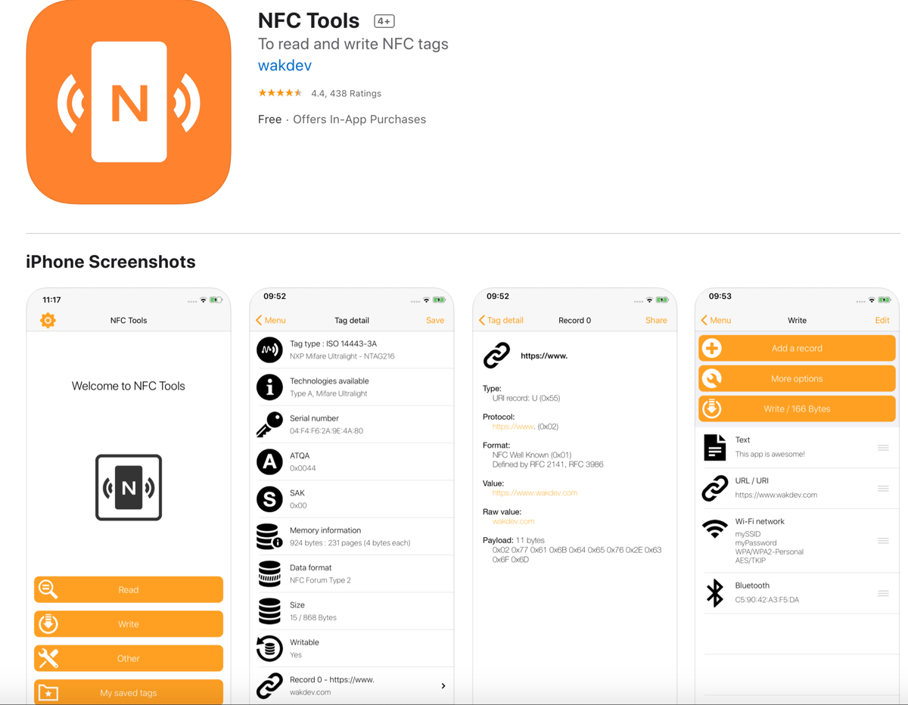

NFC Tools has been tested with the following NFC tags:
- NTAG 203, 210, 210u, 212, 213, 213TT, 215, 216
- Ultralight, Ultralight C, Ultralight EV1 (Type 2)
- DesFire (Type 4)
- FeliCa (Type 3)
- ICode (Type 5)

